Total Segment Aggregations Query
The results show performance metrics across seven channels, where Organic Search captures the largest customer base (130) while Google Ads leads in overall revenue generation ($1,467,624).

QUERY-;
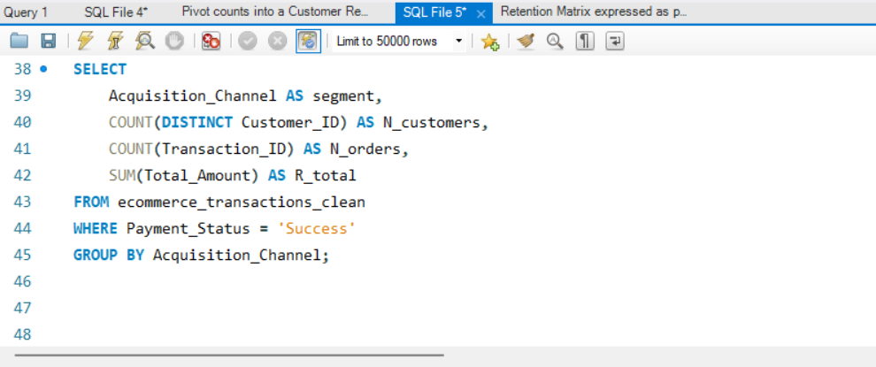

OUTPUT-;
